Ex.no:6 | DATA VISUALIZATION USING POWER BI (DIABETIC DATA)

Aim:
To clean, preprocess, and transform the diabetic patient dataset, load the data into Power BI, and create an interactive dashboard to analyze patient encounters, hospital stay duration, readmission patterns, patient demographics, insulin usage, and age-wise readmissions.
Algorithm:
- Import Dataset: Load diabetic_data (1).csv into your environment.

- Data Preparation: Identify the required patient, demographic, hospital stay, medication, and readmission fields for analysis.

- Handle Data Types: Ensure fields such as age, gender, race, insulin, readmitted, A1Cresult, change, and time_in_hospital have appropriate data types.

- Load Clean Data: Load the prepared diabetic patient data into Power BI Desktop via Get Data > Text/CSV.
- Create Core Metrics:
-click the table name → Select New Measure.
Define measure: Total Encounters = COUNTROWS('diabetic_data (1)')
- Create Additional Measures:

Define measure: Readmissions (<30 Days) = CALCULATE( COUNTROWS('diabetic_data (1)'), 'diabetic_data (1)'[readmitted] = "<30" )

Define measure: Avg Hospital Stay = AVERAGE('diabetic_data (1)'[time_in_hospital])

- Create Visual Dashboard:
Create Card visuals for Total Encounters, Avg Hospital Stay, and Readmissions (<30 Days).
Create slicers for gender, readmitted, and age.
Create a Donut Chart using insulin and Total Encounters.
Create a Clustered Column Chart showing Readmissions (<30 Days) by age.
Create a Matrix using A1Cresult, change, Readmissions (<30 Days), and Total Encounters. Arrange the visuals into an interactive dashboard for diabetic patient analysis.

Output:

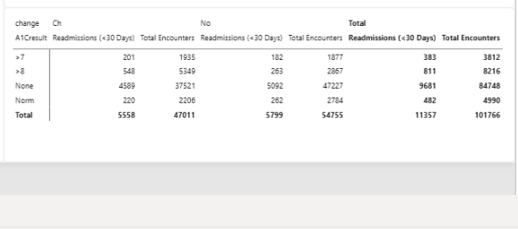

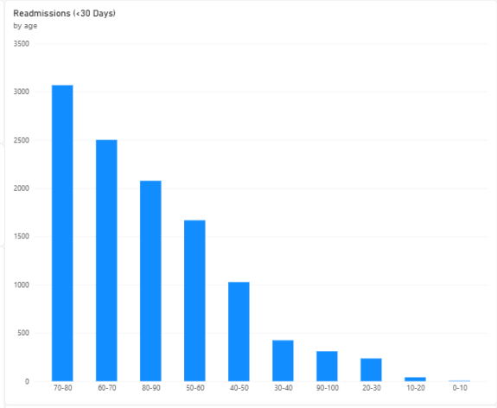

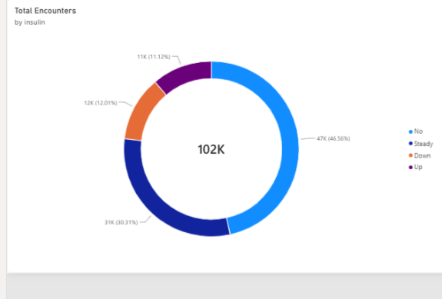

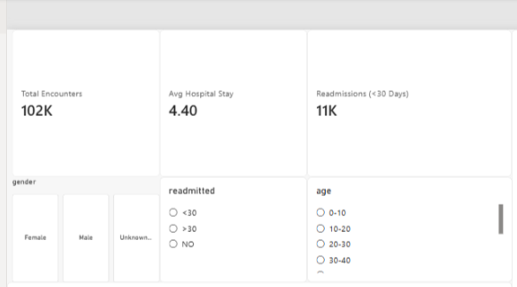

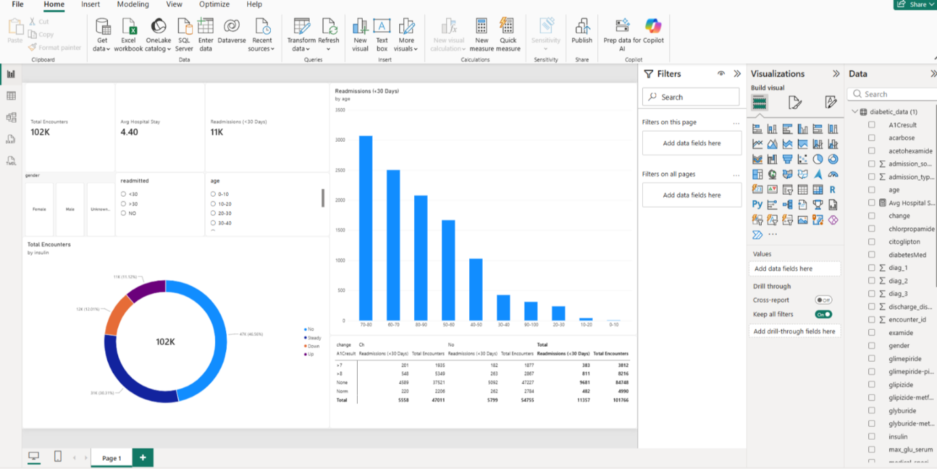

Result:

